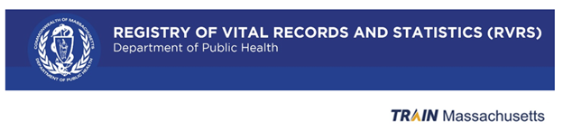
Reset Password
Purpose: The purpose of this document is to inform you how to reset your password using the “Forgot Password” functionality in TRAIN.
- Click on the “Forgot Password” button from the TRAIN Login screen.
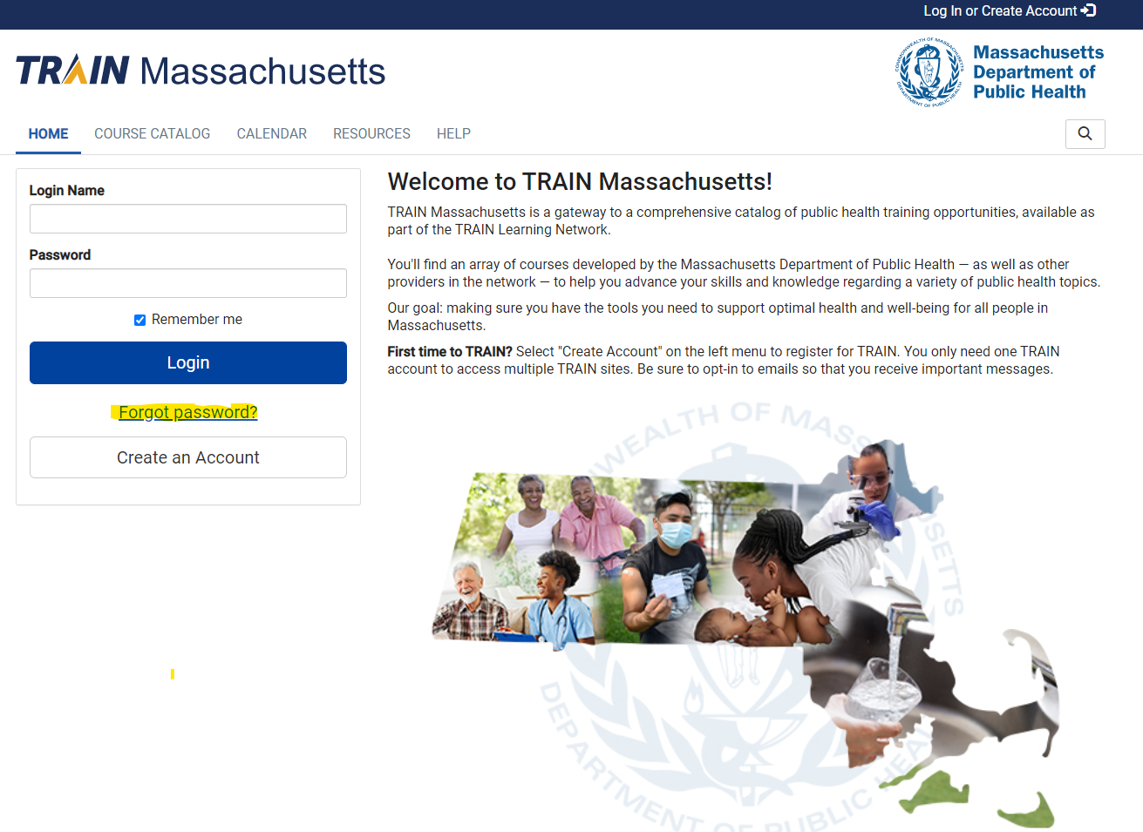
- Enter the email address associated with your account on the following screen.
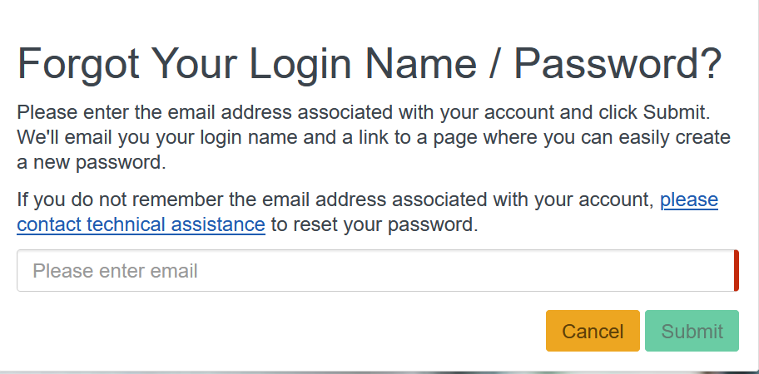

- Click on the “Submit” button.
- The following message will display stating “Please check your e-mail”.
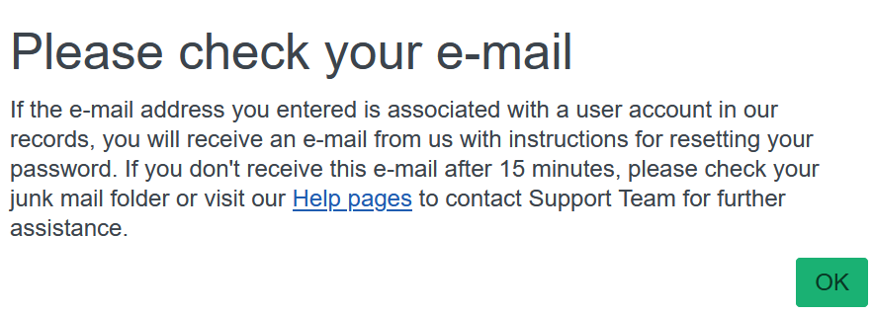
- Click on the “OK” button.
- Check the email associated with your TRAIN account.
- You should receive the following email.
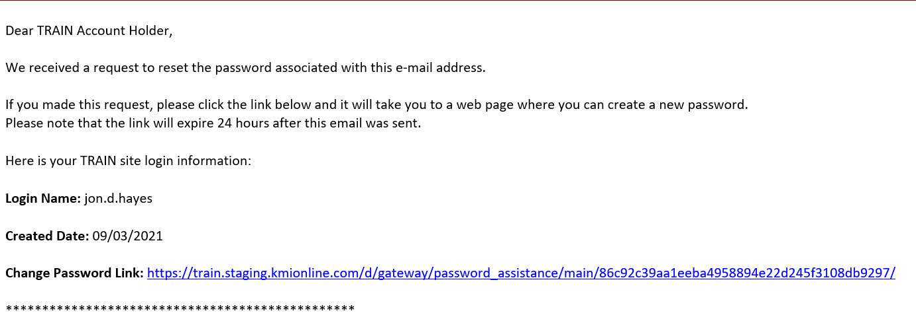
- Click on the blue “Change Password” link.
- The Password Assistance screen will display.
- Enter and confirm the new password.
Password must:
- Contain at least one lower case letter.
- Contain at least one upper case letter.
- Contain at least one number.
- Be at least 8 characters.
- Be different from your login name, first name, last name, and email address.

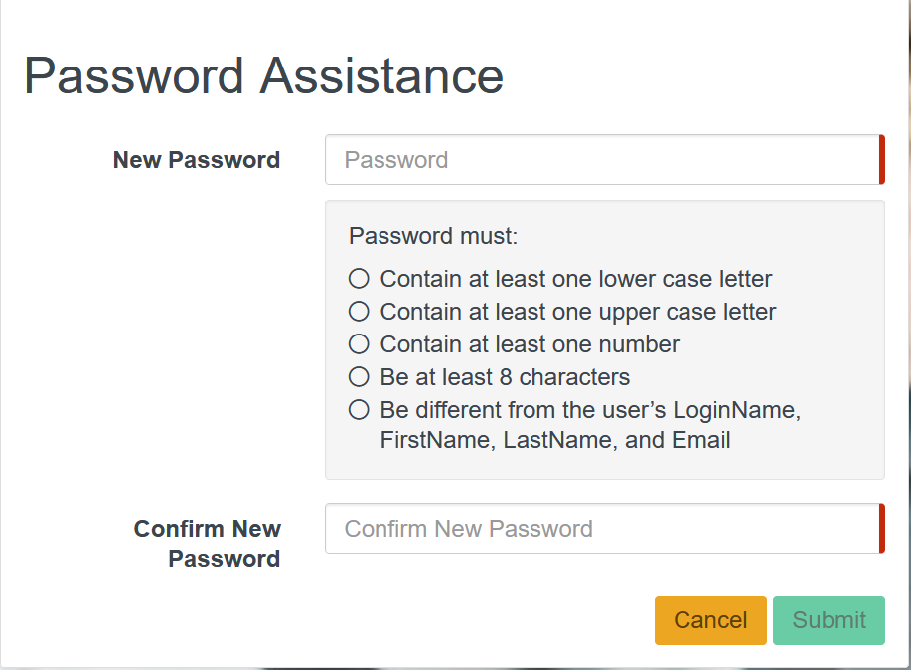
- Click the “Submit” button.
- The user will receive confirmation that the password was changed successfully.
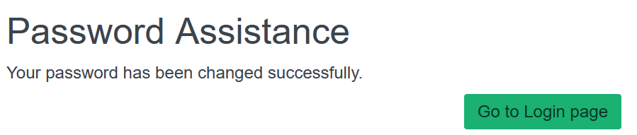

End
Attention: Please send an email to DPH-TRAINHelp@mass.gov for TRAIN related inquiries and additional support.

